**Background**

To have a quantitative analysis of intestinal drug absorption and to study its kinetics we decided to use the Compartment Analysis And Transit (CAT) model. Despite the oral absorption process being complex and difficult to predict, most drugs are administered orally. Because of this complexity, computational physiologically based pharmacokinetic (PBPK) models have emerged as a tool to mechanistically capture the process of drug absorption. These models use inputs from in vitro assays to predict the pharmacokinetic behaviour of drugs in the body. The most common oral PBPK models are compartmental approaches in which the gastrointestinal tract is characterized as a series of compartments through which the drug transits. Two fundamental processes describing drug absorption include the dissolution of the drug into gastrointestinal fluid and permeation of dissolved drug through the intestinal wall. These processes are complex and are governed by physicochemical properties such as the compound solubility and permeability. Other external properties such as pH environment and metabolic enzymes in the GI tract also play an important role in drug absorption.

**CAT MODEL**

The compartmental absorption and transit model extends the mixing tank model to characterize the drug transit through the GI tract. Seven compartments are used to describe absorption and transit through the small intestine. The CAT model was originally developed to predict drug absorption for non-degradable drugs, still this model was shown to capture the dependence of a fraction of dose absorbed on the effective permeability for various drugs with different absorption characteristics.

By incorporating the Michaelis Menten kinetics for carrier/transporter mediated absorption , gastric emptying rate constant, compartment dependent degradation rate constant, the CAT model was extended for predicting the dose-dependent drug absorption with degradation in the small intestine. The CAT model was later extended to simulate the fraction of the dose absorbed in controlled release dosage forms . The compartment transit times in the duodenum, jejunum and the ileum are 14, 71 and 114 min respectively. The CAT model also provides an insight into the physicochemical properties (such as solubility and permeability) and dosage form variables on the oral drug absorption.

In our case, we have used the CAT model to understand the transit flow in the small intestine and estimate the relative drug absorption in each compartment of the small intestine. Our objective is to show that our drug is absorbed the most in the duodenum.

.

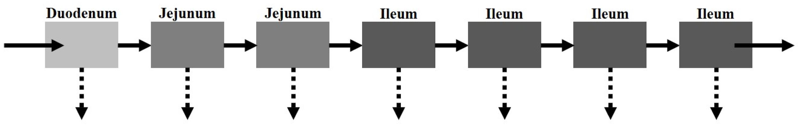

**Schematic of the compartmental absorption and transit (CAT) model. The small intestine is separated into seven compartments. The solid and dotted arrows represent the transit rate constant (*kt*) and absorption rate constant (*ka*), respectively**

**SPECIFICITIES OF OUR PILL**

Our probiotic is loaded into PEGylated PLGA microspheres which are loaded into an HMTC enteric pill. The microspheres will be released in the proximal part of the duodenum. These PEGylated microspheres will diffuse through the mucus of the intestine to reach the intestinal wall to release the probiotic. For a normal small molecule drug, the absorption constant is determined by the intestinal effective permeability. In our case, instead of being absorbed by the enterocytes, the microspheres are being absorbed by the mucosal layer. Hence, we can define a parameter analogous to the intestinal effective permeability for this specific case.

**ASSUMPTIONS MADE IN CAT MODEL**

* Dissolution is instantaneous
* A drug moving through the small intestine can be viewed as a process flowing through a series of segments, each described by a single compartment with linear transfer kinetics from one to the next, all compartments may have different volume and flow rates but have the same residence time.

Therefore for a non-degradable drug dosed in an immediate release dosage form the absorption and the transit in the small intestine can be depicted as follows :

**Equations in the small intestine:**

The human small intestine transit flow can be described by seven compartments where the transfer of drug from one compartment to the next is represented by linear first-order differential equations. The ODEs are as follows :

$\frac{dM_{1}}{dt}= -k_{t}{M_{1}-k_{a}M_{1}}_{}$

$\frac{dM_{2}}{dt}=k_{t}{M_{1}-k_{t}M_{2}-k_{a}M_{2}}_{}$

$\frac{dM_{3}}{dt}=k_{t}{M_{2}-k_{t}M_{3}-k_{a}M_{3}}_{}$

$\frac{dM_{4}}{dt}=k_{t}{M_{3}-k_{t}M_{4}-k_{a}M_{4}}_{}$

$\frac{dM_{5}}{dt}=k_{t}{M_{4}-k_{t}M_{5}-k_{a}M_{5}}_{}$

$\frac{dM_{6}}{dt}=k_{t}{M_{5}-k_{t}M_{6}-k_{a}M_{6}}_{}$

$\frac{dM_{7}}{dt}=k_{t}{M_{6}-k_{t}M_{7}-k_{a}M_{7}}_{}$

where,

$k_{t}=\frac{7}{TSE}$ and $k_{a}=\frac{2{*P}_{eff}}{ R}$

$M_{n}$*is the amount of drug in the $n^{th}$ compartment*

*TSE is the time of gastric emptying*

$k_{t}$*and $k_{a}$ are the rate constants for small intestine transit and intrinsic absorption.*

$P_{eff}$*is the effective permeability of the through the mucus (analogous to the intestinal effective permeability of small molecule drugs)*

*R is the radius of the intestine.*

**Equations for drug absorption:**

*The generalized equation for drug absorption can be given by:*

* $\frac{dM_{a,n}}{dt}= {{}_{}k_{a}M_{n}}_{}$*for n = 1 to n=7*

$M_{n}$*is the amount of drug in the $n^{th}$ compartment and $k_{a}$ rate constant for intrinsic absorption.*

*Ma,n  denotes the amount of the drug absorbed in the nth  compartment*

**Equation for Fa,n (Fraction of drug absorbed in each compartment)**

$F_{a,n }=\frac{\int_{0}^{t}{}k_{a}*M_{n}*dt}{M_{0}}$*where $M_{0}$ is the initial drug concentration (t was calculated using steady-state approximations of Ma,n - T graph).*

**RESULTS**

**Drug concentrations in each compartment of the small intestine**

**( For Ka= 1 and 3 hour-1 respectively)**

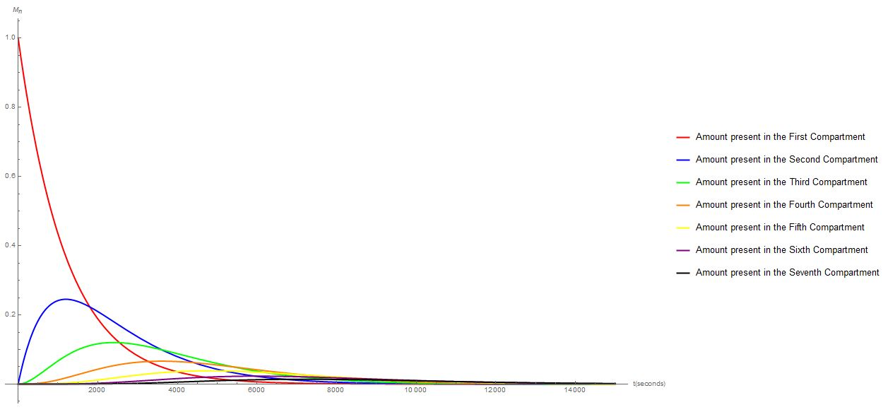

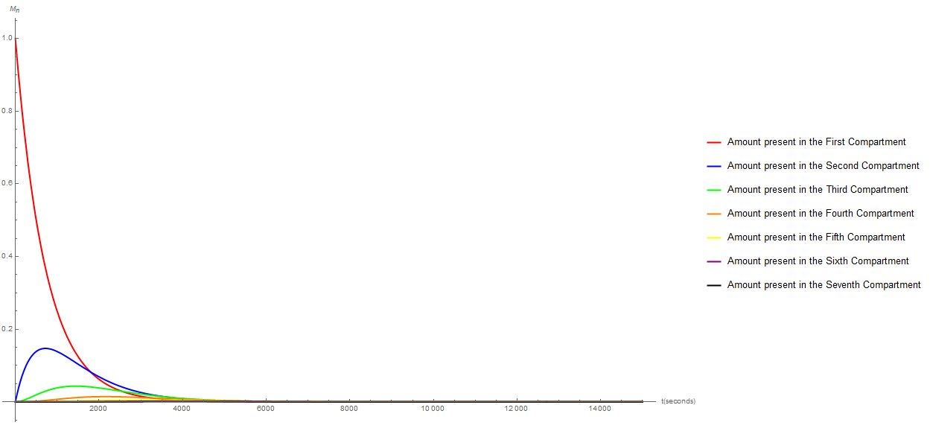

The graph depicts the amount of drug present in each compartment of the intestine at time t, for the first compartment (duodenum) just the outflow is considered and hence the concentration of the drug decreases with the time. For all the next six compartments the inflow of the drug from the preceding compartment and its outflow to the succeeding compartment is also considered, hence the drug concentration initially reaches a maximum and then begins to decrease for the remaining six compartments.

**Drug absorption in each compartment ( For Ka= 1 and 3 hour-1 respectively)**

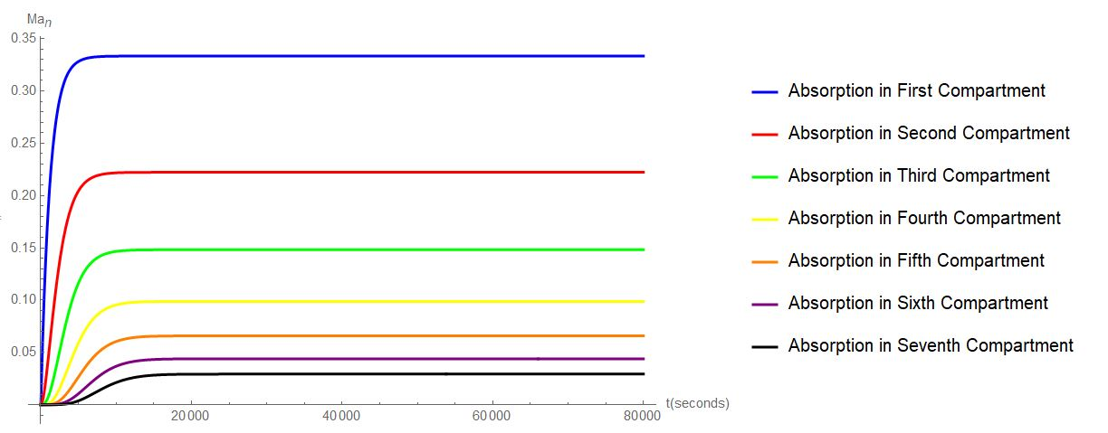

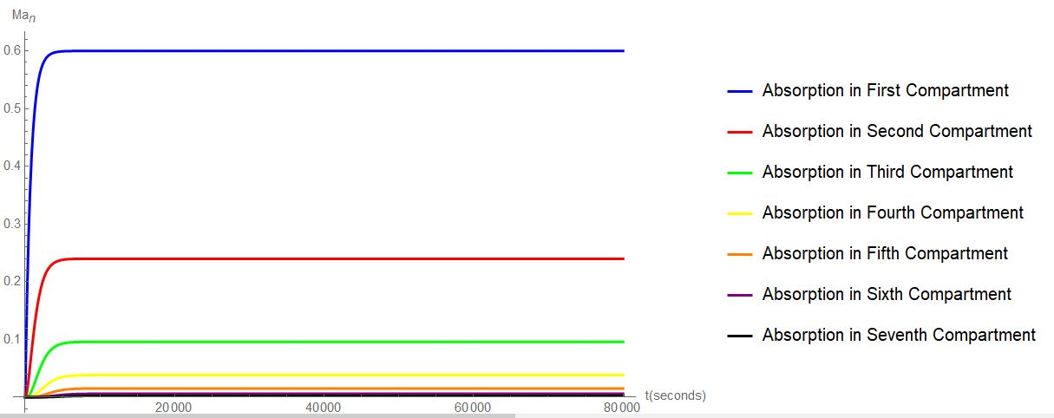

On solving the ODEs for the drug absorption the plots for compartment-wise drug absorption were generated. As expected the initial compartments showed the maximum absorption and the later compartments the least. In our case, the microsphere absorption has to be maximum in the duodenum and jejunum (first 2-3 compartments), hence an optimal ka value was selected that gave us the desired outcomes. Optimal results were produced for ka greater than or equal to 3 hour-1and the corresponding $P_{eff}$ value can be calculated.

.

**CONCLUSIONS**

The CAT model describes the small intestine transit and the absorption process if the assumptions are satisfied. However, due to lack of experimental data regarding $P_{eff}$ (which is analogous to the intestinal effective permeability), we couldn't obtain the $P_{eff}$ value for our microsphere. But through this model, we can get an idea about the required value. The mucosal absorption can be controlled by PEGylation. If the absorption is greater in the first few compartments, the results obtained will be better as the concentration of crypt cells are higher in the proximal part of the intestine,

**References**

* **Lawrence X. Yu , Gordon L. Amidon. *A compartmental absorption and transit model for estimating oral drug absorption*. International Journal of Pharmaceutics 186 (1999) 119–125.**
* ***A Kartono et al 2018 J. Phys.: Conf. Ser. 1120 012033*.**
* **Huang, Weili, and Sau Lawrence Lee. *Mechanistic Approaches to Predicting Oral Drug Absorption*. vol. 11, AAPS J, 2009.**
* **Lin, Louis, and Harvey Wong. *Predicting Oral Drug Absorption: Mini Review on Physiologically-Based Pharmacokinetic Models*. pharmaceutics, 2017.**